ABSTRACT

Hydrogen's ignition properties made it as a fit fuel to battle the current circumstances of consumption of the non-renewable energy sources and to defend the natural contamination issues. Its energy content per unit mass and higher warming worth is practically around three times that of current petroleum derivatives. Hydrogen touches off across a wide scope of fixations, from around 4 to 74 percent, and just requires a limited quantity of energy to start. Besides when hydrogen responds with oxygen to produce energy, the subsequent response item is water fume. Taking into account the above hydrogen can be utilized as a fuel in inside burning motors or then again in power module vehicles. In this paper an exhaustive survey was made to bring mindfulness among mate analysts dealing with hydrogen about ignition basics, its irregularities, fuel enlistment systems, execution, emanation and security related angles for using it in IC Motors as an elective fuel. Flammable gas is a combination of hydrocarbons, fundamentally methane, and is delivered either from the gas wells or in formation of unrefined petroleum creation. Petroleum gas is burned-through in the private, business, mechanical, and utility business sectors. Flammable gas can either be put away installed a vehicle as packed gaseous petrol (CNG) or as melted petroleum gas (LNG). Flammable gas can likewise be mixed with hydrogen. The cost saving is immense along with reduced emissions and environment friendly.

**CONTENTS**

**DISCRIPTION**

Page no

Abstract

**1 INTRODUCTION**

* 1. History of gaseous fuels
  2. Types of gaseous fuels
  3. Natural gas as fuel
     1. Natural gas Production
     2. Combustive properties of Natural gas
     3. Use of Natural gas in fuel cell vehicle
     4. Use of Natural gas in IC engines
        1. Use of Natural gas in SI engines
        2. Use of Natural gas in CI engines.
  4. Chemical Reactions
  5. References
  6. Pros of natural gas
  7. Future Natural Gas

LIST OF FIGURES

Table no. Title Page no.

1.2.(a) Types of gaseous fuels 2

1.3.4.1(a) Natural gas in SI engines 5

1.3.4.2(b) Natural gas in CI engines 6

CHAPTER 1

* 1. **History of gaseous fuels**

Many fuel gasses are compressed of hydrocarbons (such as methane or propane). The distribution through pipes is occurred due to the potential of light and heat using gas as a source. Such gases are wellsprings of potential warmth energy or light energy that can be promptly communicated and conveyed through pipes from the starting place straightforwardly to the spot of utilization.

Fuel gas is appeared differently in relation to fluid powers and from strong energizes, however some fuel gases are condensed for capacity or transport. While their vaporous nature enjoys benefits, staying away from the trouble of shipping strong fuel and the risks of spillage innate in fluid energizes, it additionally has restriction. It is feasible for a fuel gas to be undetected and gather in specific regions, prompting the danger of a gas blast. Therefore, odorizes are added to most fuel gases so they might be distinguished by an unmistakable smell. The most widely recognized kind of fuel gas in current use is flammable gas.

* 1. **Types of gaseous fuels**
* Fuels naturally found in nature
  + Natural gas
  + Methane from coal mines
* Fuel gas made from solid fuel
  + Gasses derived from coal
  + Gasses derived from waste and Biomass
  + Gasses derived from other industrial purpose
* Gasses made from petroleum
  + Liquified Petroleum gas (LPG)
  + Refinery gases
  + Gas from oil gasification
* Gas from fermentation process
  + For the same pressure drop is the heat release roughly the same
  + For the same air and fuel flows is the flame shape is same
  + For the same heat release conditions are pollutants within a specified tolerance.

**1**

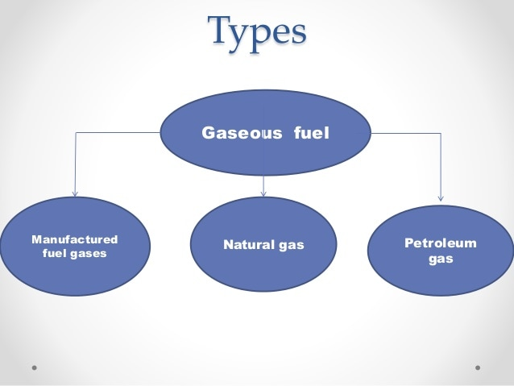

* 1. **Natural gas fuel**
     1. **Natural gas production**

On the off chance that the outcomes from a test well show that a geologic development has sufficient petroleum gas to create and make a benefit, at least one creation wells are penetrated. Petroleum gas wells can be bored upward and on a level plane into flammable gas bearing arrangements. In traditional petroleum gas stores, the flammable gas by and large streams effectively up through wells to the surface. In the United States and in a couple of different nations, flammable gas is delivered from shale and different sorts of sedimentary stone arrangements by driving water, synthetics, and sand down a well under high tension. This cycle, called water powered cracking or deep earth drilling, and now and then alluded to as offbeat creation, separates the development, delivers the flammable gas from the stone, and permits the gaseous petrol to stream to and up wells to the surface. At the highest point of the well on a superficial level, gaseous petrol is placed into social occasion pipelines and shipped off petroleum gas preparing plants.

**2**

* + 1. **Combustive properties of Natural gas**

Combustion of natural gas is the chemical reaction of oxygen with a combustible material

which produces heat.

There are three requirements for combustion. If one of these three components is missing, combustion cannot occur.

* Fuel (natural gas)
* Oxygen
* A source of ignition.

The flammable range of natural gas is in the range of 4% to 15% gas as per the volume of air.

Above and below, these amounts it will not burn. The natural gas is most efficient at about 10% gas.

A combustible mixture of natural gas with air also has a very high ignition temperature of about 1150°F, which is almost twice the ignition temperature for gasoline. Here are possible sources of ignition:

* Any open flame such as a pilot light, match, or lighted candle.
* Static electricity spark.
* Light switch.
* Heating element or motor in an electric appliance.
* Internal combustion engine, while running or starting.
* Overhead electrical transformer.
* A ringing doorbell

Gaseous petrol is lighter than air, so it can scatter into the air quickly, making unintentional ignition troublesome. It's additionally drab, non-poisonous, and had no desire for its normal state. When taken starting from the earliest stage, gas is scentless. PNG adds a non-harmful synthetic odorant called mercaptan to make releases simple to smell. Be that as it may, there might be times when the smell of the odorant is feeble or not present, despite the fact that there is a break.

Properties that contribute to its use as a combustible fuel are:

* Wide range of flammability :4% to 75% at 25 C
* Low ignition energy :0.02mj
* Small quenching distance: 0.064 cm
* High auto ignition temperature: 585 C
* High octane number: 130
* High flame speed
* High diffusivity
* Very low density
* Hydrogen flames are very pale blue are most invisible in daylight due to the absence of soot.

**3**

Out and out, these elements amount to making inadvertent start or ignition of petroleum gas an improbable occasion. Regardless, assisting you with figuring out how to utilize clean consuming flammable gas securely all through your house is one of our top proprieties. It is significant for you and your family to comprehend flammable gas and related wellbeing data.

* + 1. **Use of natural gas in fuel cell vehicle**

In the United States, gaseous petrol is utilized fundamentally for power age and private, business, furthermore, mechanical applications, however it is likewise utilized as a fuel for on-street vehicles, particularly in medium-or rock-solid vehicles in centrally fuelled armadas. It has been proposed for more noteworthy use as a fuel for on-street vehicles, especially in light-obligation vehicles. This can mean consuming petroleum gas in an inward burning motor like those utilized in most petroleum gas, fuel, diesel-controlled vehicles on the street today. Notwithstanding, flammable gas can likewise fill in as the fuel source for module electric or hydrogen energy component electric vehicles. This reality sheet looks at some productivity and natural measurements for three potential alternatives for utilizing normal gas in light-obligation vehicles. The investigation introduced here looks at these pathways. It's anything but expected to suggest for or against expanded utilization of normal gas in light-obligation vehicles. Related progressing examination thinks about use of natural gas with these three innovation pathways in medium or uncompromising vehicles (for instance, in halfway filled armadas that utilization huge amounts of fuel), however won't be shrouded in this reality sheet. This examination of pathways in light-obligation vehicles depends on a point-by-point examination. which utilizes the Welcome model (Greenhouse Gases, Managed Emissions, and Energy use in Transportation). Researchers at Argonne National Laboratory created GREET to assess energy use and discharges across the whole fuel life cycle from extraction to end use in transportation.

* + 1. **Use of natural gas in IC engines**
       1. **Use of natural gas in SI engines**

Ahrenfeldt studied the fuelling of biomass producer gas on a combined heat and power (CHP) engine and its long-term effect. Emission, performance, efficiency, and other operating parameters were investigated when producer gas produced from three different gasification plants with their lower heating values 5.5, 6, and 12.1 MJ/Nm3 were engaged in the combined heat and power operations. Based on the performance study, it was reported that producer gas is an excellent fuel for lean burn application; its lean limit was close to an excess air ratio (λ) of 3.00. There was no effect of variation of ignition timing on the power and efficiency. However, ignition timing was observed to affect the emission level of NOx. The emission level of NOx was reported to be low. On the other hand, CO emission was observed to be very high due to the higher content of CO in the fuel. On the combustion study, the coefficient of variation (COV) of the IMEP and mass fraction burn (MFB) remained constant for the producer gas even when λ increased.

Mustafi et al investigated performance and emission of power gas in a variable compression ratio SI engine and further compared it with that of gasoline and CNG. The composition of power gas was mainly H2, CO, and CO2 similar to that of medium calorific value syngas produced from the gasification of solid fuels. However, the production of this fuel was through Aqua-fuel process. The molar ratio of the fuel investigated was 0.52, 0.44, and 0.04

**4**

for CO, H2 and N2, respectively. The lower heating value of the gas was 15.3 MJ/kg. The stoichiometric air-fuel ratio of the gas was observed to be 4.2 as compared to 14.6 and 15.5 for gasoline and CNG, respectively. A Ricardo single cylinder SI engine with a variable compression ratio was modified to accompany a gas mixer, gas regulator, and needle valve setting to accommodate the fuel-air blending before the cylinder. On their comparison of power output of this gas at different compression ratios, an improvement of 22% was reported by increasing the compression ratio from 8: 1 to 11: 1. The power output of this gas, gasoline and CNG was compared at constant speed of 1500 rev/min. It was reported that the brake torque of power gas was 30% and 23% lower than that of gasoline, and CNG,

respectively. The fuel consumption was also compared and power gas was requiring 2.7 and 3.4 times more than that of gasoline and CNG, respectively. However, consumption was not affected with the change in compression ratio. Emissions of total hydrocarbon (THC) and CO of power gas were observed lower than for gasoline and CNG. However, CO2 and NOx emissions were higher than all these fuels. These experimental results were compared with simulation model and were found to be consistent at all conditions.

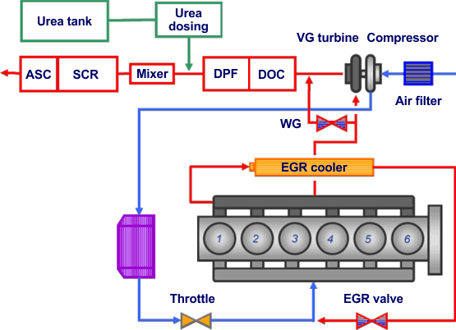

Papagiannakis et al have numerically modelled the combustion process of a four-stroke, turbocharged, water-cooled, multicylinder SI GE Jenbacher 320 engine fuelled with syngas. The fuel is a product of gasification of wood with a volume percentage composition of 19% H2, 29% CO, 6% CH4, 8% CO2, and 38% N2. The two-zone model predicted in-cylinder pressure profile, heat release rate, nitric oxide (NO), and CO concentrations. The model results were validated by the experimental results from the same engine operated at constant speed of 1500 rev/min at four conditions of 40, 65, 85, and 100% of full load. Their observation mainly focused on the validation of the numerical model. Moreover, they discussed the combustion, performance, and emission characteristics of syngas in comparison with CNG.

**5**

* + - 1. **Use of natural gas in CI engines**

Severe guidelines towards the discharges from diesel motors are limiting improvement of the most effective ICE. Use of syngas in diesel motors is viewed as a reasonable option both for the emanations and energy emergencies. In any case, syngas has high self-started temperature (normally above 500°C) and accordingly, it can't be lighted by pressure start in a diesel motor. A potential method of using syngas in the CI motor is through double fuelling, where diesel is infused as a pilot fuel to start the start while syngas infused into the acceptance framework. The principal inspiration in utilizing syngas and other vaporous powers in diesel motor is as a substitute to diesel as this can therefore decrease cost, limit emanations (NOx and particulate matters), and increment the motor exhibition.

There are numerous reports on research in regards to syngas double fuelling in CI motor. Azimov et al examined the impact of H2 and CO2 substance in syngas on the exhibition and discharge of a four-stroke single chamber motor. Diesel was utilized to help the autoignition of syngas in a pilot-fuel mode under lean condition for a wide scope of proportionality proportion (ϕ). The motor was supercharged and worked in a premixed blend start in the end-gas district (PREMIER). Head ignition was noticed for all syngas powers, chiefly when the pilot fuel utilized is little. This ignition was noticed upgrading the presentation and expanding the effectiveness of double fuelling. Moreover, they announced that an expansion in hydrogen arrangement in syngas abbreviated the principal ignition length and subsequently causing an expanding in the mean burning temperature, shown mean powerful pressing factor (IMEP), and effectiveness. Nonetheless, neither diesel could be totally subbed nor could syngas remain solitary as a fuel in a diesel motor in the examination.

Sahoo et al researched the second law investigation of a solitary chamber DI CI motor fuelled with syngas under a double fuel mode, where diesel filled in as a pilot fuel. The impact of H2/CO proportion on the double fuel motor execution and thermomechanical accessibility of the motor was considered. The impersonation syngas was made out of H2 and CO blended in a gas blender and was dashed into the gas carburettor. The analysis was directed at various burden conditions going from 20 to 100% with a 20% stretch. They announced that the syngas double fuel had a superior work accessibility at higher loads when contrasted with diesel fuelling. Moreover, an expansion in the substance of hydrogen in syngas further developed the work accessibility of the double fuelling. In a different report, similar analysts examined the impact of H2/CO proportion on the presentation of a double fuel motor under a similar test condition. The exhibition boundaries inspected in the examination were brake warm proficiency, diesel replacement, pressure profile, most extreme chamber pressing factor, and fumes gas temperature. Likewise, the subsequent emanations like CO, NOx, and hydrocarbon (HC) were additionally researched. The syngas H2 and CO synthesis were 50: 50, 75: 25, and 100% in volume rate. They saw that an increment in H2 in the syngas brings about an expansion in the brake warm effectiveness. The most noteworthy diesel supplanting with syngas and greatest in-chamber pressure was seen at 80% burden with 100% H2. On emanations, NOx was seen to increment with H2 content in syngas. As expected, the CO discharge was straightforwardly identified with the CO substance in syngas. The HC outflow was discovered to be least with 100% H2.

Wagemakers and Leermakers evaluated the impact of double fuelling of diesel and diverse vaporous powers on execution and discharge. CNG, fluid oil gas (LPG), syngas, and hydrogen were a portion of the vaporous fills considered in their survey. They revealed that every single vaporous fuel, when applied in diesel fuel ignition as double fuel, could diminish residue outflows with the exception of syngas. Decrease in NOx was accounted for when both CNG and LPG were utilized as essential energizes. Notwithstanding, burning of syngas and hydrogen expanded the NOx level when contrasted with diesel. Unburned hydrocarbons and CO emanations expanded with double fuelling of the relative multitude of vaporous powers when contrasted with diesel alone. Concerning the impact of these energizes on proficiency, hydrogen and LPG influenced decidedly while syngas and CNG influenced contrarily.

The presentation of a double fuel mode pressure start motor filled by syngas with a piece of 10% H2, 25% CO, 4% CH4, 12% CO2, and 49% N2 and diesel (as pilot fuel) was contrasted and that of methane under a similar dual fuel course of action. For both two fuel blends, a shift from dispersion fire burning to proliferation fire ignition was accounted for with decrease of the pilot diesel fuel. Generally, methane was displayed to perform better when contrasted with syngas in the dual fuelling mode for diesel replacement.

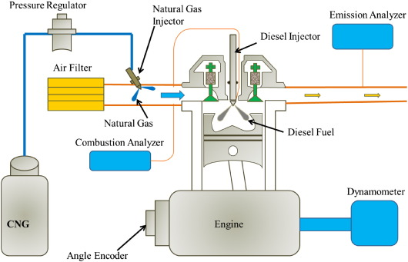

In rundown, a total supplanting of diesel fuel with syngas couldn't be conceivable. Moreover, the presentation of such double fuelling of syngas and diesel was more unfortunate when contrasted with double fuelling of CNG and diesel. Accordingly, syngas can't be a solid substitute to diesel fuel in CI motors. Notwithstanding, it tends to be utilized as a valuable fuel to decrease cost and discharges of NOx and particulate matter.

**6**

* 1. **Chemical Reactions**

In incomplete oxidation, the methane and different hydrocarbons in petroleum gas respond with a restricted measure of oxygen (commonly from air) that isn't sufficient to totally oxidize the hydrocarbons to carbon dioxide and water. With not exactly the stoichiometric measure of oxygen accessible, the response items contain essentially hydrogen and carbon monoxide (and nitrogen, if the response is completed with air as opposed to unadulterated oxygen), and a moderately modest quantity of carbon dioxide and different mixtures. Therefore, in a water-gas shift response, the carbon monoxide responds with water to frame carbon dioxide and more hydrogen.

Incomplete oxidation is an exothermic cycle—it emits heat. The cycle is, normally, a lot quicker than steam transforming and requires a more modest reactor vessel. As can be found in compound responses of incomplete oxidation, this interaction at first creates less hydrogen per unit of the info fuel than is acquired by steam improving of a similar fuel.

Partial oxidation of methane reaction

CH4+1/2O2 🡪 CO +2H2+(heat)

Water gas shift reaction

CO+H2O 🡪 CO2+H2 + (small amount of heat).

* 1. **Pros of natural gas:**
* Lower emissions.
* Lower smog producing gasses (60-90% Light duty use, 90% in Mid to Heavy-duty use)
* Can be used to make hydrogen to power the future fuel cell technology.

**1.6. Future of natural gas:**

* Natural gas is now being installed in 1 out of 5 transit busses today.
* Fuelling systems are installed in home or public facilities
* Gradually the automobiles shift to natural gas fuel.

**7**